
Invention Disclosure Form

Name of the Department: Computer Science and Engineering
The purpose of this form is to obtain a description of your invention to assist in the patent process. Please answer the following questions as well as possible. Attach additional sheet(s) if needed.
- TITLE: Provide a title that is descriptive of your invention:
Understanding the Performance of AI Algorithms in Text-Based Emotion Detection for Conversational Agents
- Names of the student INVENTOR (with Roll number):
B.Snehitha Reddy - 22EG105G08
Ch.Satwik Reddy - 22EG105G11
G.Rohith Reddy - 22EG105G18
P.Varshith - 22EG105G45

- Names and designation of the faculty in charge:
Mrs. K. Rashmi
Assistant Professor
Department of Computer Science and Engineering

- Description Of the Invention:
The proposed invention is an Emotion-Aware Conversational Chatbot that combines real-time emotion detection with empathetic response generation to create human-like, emotionally intelligent conversations.
The system operates in two stages. First, the user's text message is analyzed by a fine-tuned DistilRoBERTa transformer model (emotion-english-distilroberta-base) hosted locally on the backend. This model classifies the user's emotional state into one of seven categories: joy, sadness, anger, fear, surprise, disgust, or neutral, along with a confidence score.
Second, the detected emotion is used to dynamically construct a system-level prompt that is injected into a Large Language Model (Groq API – LLaMA 3 70B). This prompt instructs the LLM to adapt its response tone and style to match the user's emotional state. For example, if sadness is detected, the LLM is prompted to respond with warmth, empathy, and gentle support. If anger is detected, the LLM is instructed to remain calm, respectful, and de-escalating.
The system also maintains a multi-turn conversation memory, preserving the full context of each chat session. This allows the chatbot to deliver coherent, context-aware responses across extended interactions.
Unlike traditional chatbots that generate responses without understanding user sentiment, this system actively perceives and responds to the user's emotional state, resulting in more meaningful and human-like interactions.
- Field of the Invention:
The invention belongs to the fields of:
• Natural Language Processing (NLP)
• Affective Computing and Emotion Recognition
• Transformer-Based Deep Learning Models
• Conversational Artificial Intelligence
• Human-Computer Interaction (HCI)
Specifically, it focuses on integrating BERT-based emotion classification with Large Language Model response generation to build emotionally intelligent conversational agents.

- Main Objective:
Develop an emotion-aware conversational chatbot that detects user emotions in real-time using a BERT-based transformer model and generates empathetic, contextually appropriate responses using a Large Language Model, with full multi-turn conversation memory support.

- Secondary Objective:
• To implement a real-time emotion detection pipeline using the DistilRoBERTa transformer model for classifying text into seven emotion categories.
• To integrate the Groq API with LLaMA 3 70B model for generating high-quality, emotion-aligned conversational responses.
• To design dynamic system prompts that adjust the LLM's response tone based on detected emotions (e.g., supportive for sadness, de-escalating for anger).
• To implement an in-memory conversation management system that preserves multi-turn chat context.
• To build a modern, professional web interface with real-time emotion badges, chat management, and dark/light theme support.
• To provide CRUD operations for chat sessions including New Chat, Delete Chat, and Chat History browsing.
• To ensure clean separation of services (Emotion Service, Chat Service, Memory Service) for modularity and maintainability.
- Background of the Invention:
Traditional chatbots and virtual assistants generate responses based solely on the textual content of the user's message without understanding or considering the user's emotional state. This leads to:
• Emotionally inappropriate responses (e.g., cheerful replies to a distressed user)
• Lack of empathy and human-like interaction quality
• Poor user engagement and trust
• Inability to provide adequate emotional support

Recent advancements in Natural Language Processing (NLP) have produced transformer-based models such as BERT, RoBERTa, and DistilRoBERTa that can accurately classify emotions from text. Simultaneously, Large Language Models (LLMs) such as LLaMA, GPT, and Mixtral have shown remarkable abilities in generating coherent, contextual text.

However, most existing systems treat emotion detection and response generation as separate, disconnected processes. There is a significant gap in systems that tightly integrate real-time emotion classification with emotion-conditioned response generation in a unified, interactive chatbot application.

Research studies in affective computing demonstrate that emotion-aware systems significantly improve user satisfaction, engagement, and trust compared to emotion-agnostic systems.
- Drawbacks in them:
Existing traditional chatbot architectures have several limitations:
- Emotion Blindness – Conventional chatbots do not detect or respond to the emotional state of the user.
- Generic Responses – Responses are generated without tonal adjustment, leading to one-size-fits-all outputs regardless of user sentiment.
- Poor Empathy – Without emotion awareness, chatbots cannot provide empathetic, supportive, or calming responses when needed.
- No Emotional Context Preservation – Existing systems do not track the emotional trajectory of a conversation over multiple turns.
- Disconnected Pipelines – In systems where emotion detection exists, it is typically a standalone module that does not influence the response generation process.
- Static System Prompts – Most LLM-based chatbots use fixed system prompts that do not adapt dynamically to the user's emotional state.
- Limited User Engagement – Emotionally unaware responses lead to lower user trust, satisfaction, and continued engagement.

- Applications of the Project (where it can be use):
The Emotion-Aware Conversational Chatbot can be used in several real-world applications:
- Mental Health Support – Providing empathetic, emotionally intelligent conversational support for individuals experiencing stress, anxiety, or emotional distress.
- Customer Service – Detecting frustrated or angry customers and responding with de-escalation strategies to improve customer satisfaction.
- Educational Platforms – Adapting tutoring responses based on student emotional states (e.g., encouraging when frustrated, enthusiastic when engaged).
- Healthcare – Assisting patients with emotional well-being check-ins and providing supportive dialogue.
- Human Resources – Supporting employees in workplace wellness programs through emotionally aware interactions.
- Social Media Monitoring – Analyzing user sentiment in real-time and generating appropriate, empathetic automated responses.
- Elderly Care – Providing companionship and emotionally supportive conversations for elderly individuals.
- Crisis Helplines – Assisting crisis support services with initial triage and emotionally appropriate automated responses.

- Description of the Components/Machinery/Process: (Note for CSE background projects: Give the details of OS, System specification etc used)
System Requirements

Operating System
- Windows 10/11 / Linux / macOS

Development Tools
- Visual Studio Code
- Node.js 18+
- Python 3.10+
- Git

Platforms and APIs
    - HuggingFace Transformers (Local Model Hosting)
    - Groq Cloud API (LLM Inference)
Hardware Requirements
Component | Specification
Processor | Intel i5 / Ryzen 5 or higher
RAM | 8 GB minimum (16 GB recommended)
Storage | 256 GB SSD
GPU | Optional (CPU inference supported)
Software Components Used
Component | Purpose
FastAPI (Python) | Backend REST API framework
Uvicorn | ASGI server for FastAPI
HuggingFace Transformers | Emotion classification model pipeline
DistilRoBERTa | Pre-trained emotion detection transformer model
Groq API | LLM inference (LLaMA 3 70B)
React 18 | Frontend UI framework
Vite | Frontend build tool and dev server

- Drawings and their Description:
  - Block Diagram of the Setup:
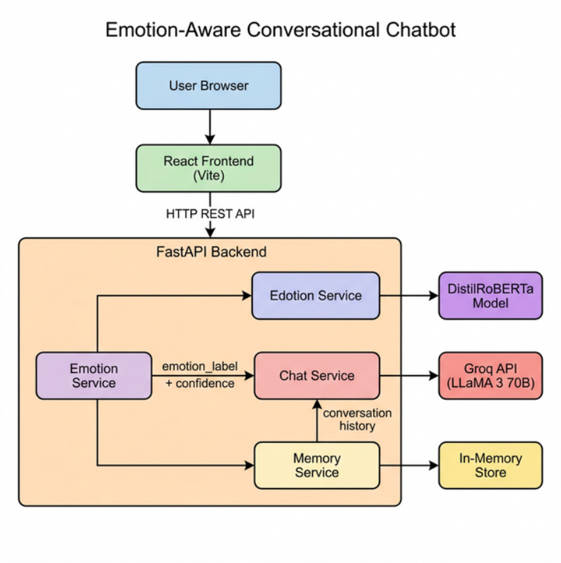
The block diagram illustrates the interaction between system components:
  - Users access the chatbot through a React web interface in their browser.
  - The frontend sends user messages to the FastAPI backend via HTTP REST API calls.
  - The Emotion Detection Service (DistilRoBERTa model) analyzes the user message and classifies the emotion.
  - The detected emotion is passed to the Chat Service which constructs a dynamic, emotion-aware system prompt.
  - The system prompt, conversation history, and user message are sent to the Groq API (LLaMA 3 70B) for response generation.
  - The LLM returns an empathetic, emotion-aligned response.
  - The Memory Service stores both user and assistant messages with emotion metadata.
  - The complete response (text + emotion badge) is returned to the frontend and rendered.

  - Flow Chart 1 (System):

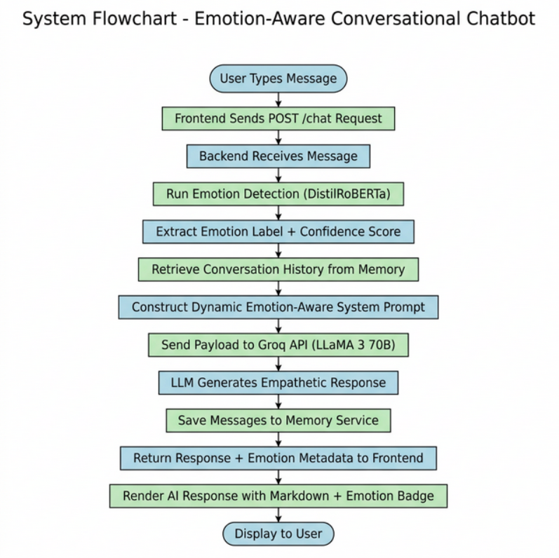
System workflow:
  - User types message in the chat interface
  - Frontend sends POST /chat request to backend
  - Backend receives message and runs Emotion Detection (DistilRoBERTa)
  - Emotion label and confidence score extracted
  - Conversation history retrieved from Memory Service
  - Dynamic emotion-aware system prompt constructed
  - Payload sent to Groq API (LLaMA 3 70B)
  - LLM generates empathetic response
  - Both messages saved to Memory Service
  - Response + emotion metadata returned to frontend
  - Frontend renders AI response with Markdown formatting and Emotion Badge

  - Flow Chart 2 (Process):
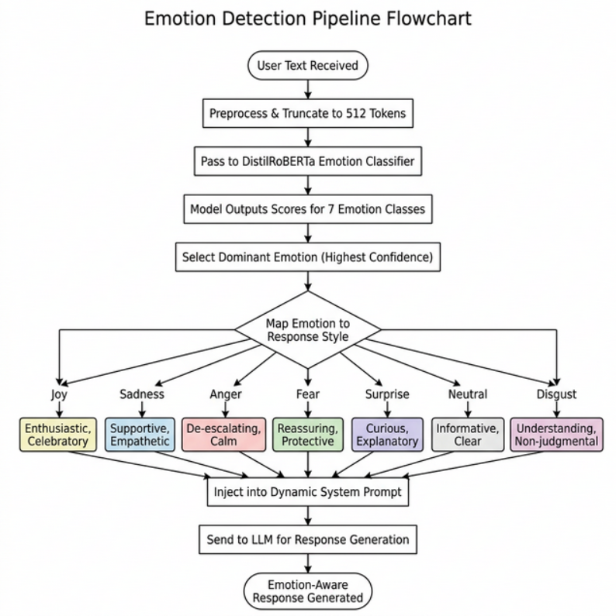

Processing workflow:
1. User text received from API endpoint
2. Text preprocessed and truncated to 512 tokens
3. Text passed to DistilRoBERTa emotion classification pipeline
4. Model outputs probability scores for all 7 emotion classes
5. Dominant emotion with highest confidence selected
6. Emotion label and confidence score returned
7. Emotion injected into dynamic system prompt for LLM
8. System prompt adjusts LLM behavior:
- Joy → enthusiastic, celebratory tone
- Sadness → supportive, empathetic, gentle tone
- Anger → de-escalating, calm, respectful tone
- Fear → reassuring, protective, calming tone
- Surprise → curious, engaged, explanatory tone
- Neutral → informative, clear, helpful tone
- Disgust → understanding, non-judgmental tone
- Novelty of the project:
The novelty of this project lies in the tight integration of real-time emotion detection with emotion-conditioned response generation in a unified conversational system where:
- Emotion detection is performed locally using a transformer model (DistilRoBERTa), ensuring privacy and low latency.
- Detected emotions are not merely displayed as metadata but actively influence the LLM's response behavior through dynamic system prompt injection.
- The system maintains an emotion history across conversation turns, allowing it to track emotional trajectories over time.
- Response tone is dynamically adapted for each of seven distinct emotion categories, creating truly empathetic and human-like interactions.
- The architecture cleanly separates Emotion Service, Chat Service, and Memory Service, enabling modular extensibility.

- Advantages:
- Real-Time Emotion Detection – The DistilRoBERTa model classifies user emotions within milliseconds, enabling instantaneous emotion-aware responses.
- Empathetic Response Generation – Dynamic system prompts ensure the LLM adapts its tone to match the user's emotional state.
- Multi-Turn Context Preservation – Full conversation history is maintained, ensuring coherent and contextually relevant responses.
- Modular Architecture – Clean separation of Emotion, Chat, and Memory services allows independent development, testing, and scaling.
- Privacy-Friendly – Emotion detection runs locally on the server, so user messages are not sent to third-party services for sentiment analysis.
- Modern User Interface – Claude-inspired clean design with dark/light theme, Markdown rendering, emotion badges, and chat management.
- Cost Efficient – Uses Groq API's free tier for LLM inference, and the emotion model runs on CPU without requiring expensive GPU hardware.
- Extensible – The architecture can be extended with database persistence, user authentication, voice input, or additional emotion models.

Name & Signature of Inventors:
B.Snehitha Reddy
Ch.Satwik Reddy
G.Rohith Reddy
P.Varshith

Signature of the faculty in charge:

Name & designation & Signature of Departmental Coordinator for the innovative projects:

Name and Signature of Head/Dean of the department:
Dr.G.Vishnu Murthy

